**Assignment: SQL Day-2**

HARSHIT KUSHMAKAR | 16896

**Test your knowledge:**

**1. The following SELECT statement executes successfully: (TRUE/FALSE)**

**SELECT last_name, gender, monthly_income AS income FROM LMS_Customer_M;**

**(TRUE)**

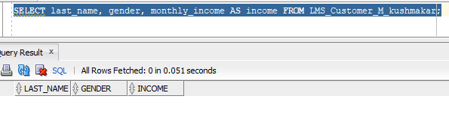

**2. The following SELECT statement executes successfully: (TRUE/FALSE)**

**SELECT * FROM LMS_Product_M; (TRUE)**

**3. There are three coding errors in the following statement. Can you identify them?**

**SELECT customer_id, last_name, monthly_income x 12 ANNUAL INCOME FROM**

**LMS_Customer_M;**

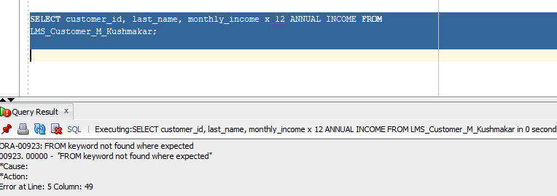

**4. The following SELECT statement executes successfully: (TRUE/FALSE)**

**select customer_id, designation from LMS_Customer_M where designation = null;**

**SQL Queries:-**

**1. Display the agreement_id, Loan_Amount, Tenure, ROI, Loan_Disbursal_Date from**

**LMS_Agreement_DTL with agreement_id appearing first.**

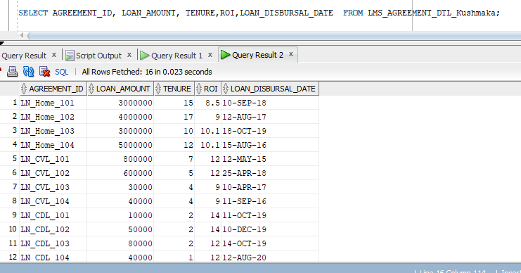

**2. Provide an alias for Loan_Disbursal_Date as DISBURSAL DATE in the above query.**

**3. Display all the unique designations from the LMS_Customer_M table**

**4. Find loans that have no disbursements recorded. Return Loan Agreement ID.**

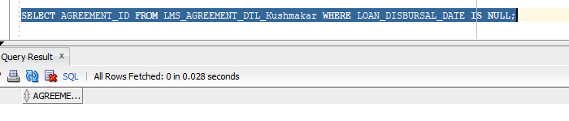

**5. Write a query to display all the loan agreements which have been disbursed in the month of**

**‘March 2020’**

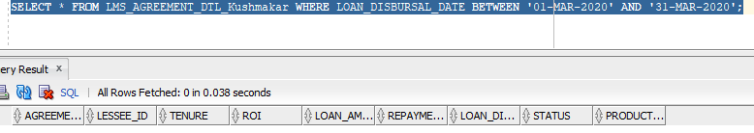

**6. Write a query to display all the loan agreements whose loan amount is greater then 5lac and**

**ROI is less than 10%**

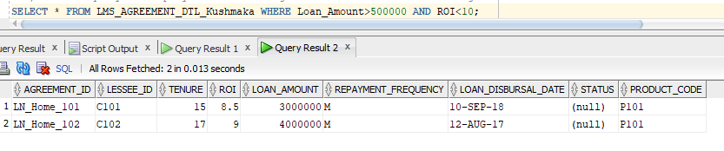

**7. Write a query to display all the instalments from LMS_PAYMENT_DTL whose status is**

**‘Completed’**

SELECT * from LMS_PAYMENT_DTL_kushmakar WHere Status = 'C';

**8. Write a query to display all the records from LMS_CHEQUE_DTL whose Payment mode is**

**either ‘Cheque’ or Draft’**

SELECT * from LMS_CHEQUE_DTL_kushmakar where payment_mode = 'C' or payment_mode = 'D';

**9. Write a query to fetch all the records from LMS_TXN_ADVICE_DTL table whose TxnType is**

**‘Installment’.**

SELECT * from LMS_TXN_ADVICE_DTL_kushmakar where txntype = 'Installment';

**10. Write a query to fetch all Product Categories from LMS_Product_Category_M table which**

**are Secured.**

SELECT * FROM LMS_PRODUCT_CATEGORY_Kushmakar where SEcuredLoan = 's';

**11. Write a query to display last_name concatenated with the designation (separated by a**

**comma and a space) from LMS_Customer_M table. Name the column ‘Customer and Title’**

SELECT concat(last_name,concat(',',Designation ) "Customer and Title *from LMS_CUSTOMER_Kushmakar;

**12. Write a query to display all the records from LMS_CHEQUE_DTL table sorted descending by Deposit_Date.**

SELECT * from LMS_CHEQUE_DTL_kushmakar order by Deposit_date DESC;

**13. Write a query to display current date. Label the column DATE.**

SELECT CURRENT_DATE AS ‘’DATE” FROM DUAL;

**14. Write a query to display all the records from LMS_CHEQUE_DTL table whose cheque_date**

**and deposit_Date are same.**

SELECT * from LMS_CHEQUE_DTL_kushmakar where Cheque_date = Deposit_date;

**15. Write a query to calculate the Penalty charges from LMS_REPAYSCH_DTL table where**

**Installment_Due_Date is less than current_date. Consider putting a penalty of Rs. 100/- per**

**day from Installment_Due_Date.**

SELECT sum(penalty_charges) from LMS_REPAYSCH_DTL_kushmakar where Installement_Date >(select sysdate as "date" from dual);

**16. Write a query to calculate the DBR percentage for each customer. The formula to calculate**

**the DBR is**

**DBR = totalmonthlyexpense/totalmonthlyincome.**

**Name the column DBR.**

SELECT(TOTAL_MONTHLY_EXPENSE/MONTHLY_INCOME) AS "DBR" FROM LMS_CUSTOMER_kushmakar;

**17. Write a query that displays the last name (with the first letter uppercase and all other letters**

**lowercase) and the length of the last name for all customers whose name starts with the**

**letters J, A, or M. Give each column an appropriate label.**

SELECT last_name "Name",LENGTH(last_name)"Length" FROM LMS_CUSTOMER_kushmakar where last_name LIKE 'J%' OR last_name LIKE 'A%';

**18. For each customer, display the first name, last name, and email address. The**

**email address will be composed from the first letter of first name, concatenated with the**

**three last letters of last name, concatenated with @nucleussoftware.com.**

SELECT FIRST_NAME,LAST_NAME,EMAIL_ADDRESS, (SUBSTR(FIRST_NAME,1,1)||(SUBSTR(LAST_NAME,-3,3)||'@nucleussoftware.com')) FROM LMS_CUSTOMER_kushmakar;

**19. Write a query to display the date of instalment_amount and date of first instalment**

SELECT First_Installment_Date, Installement_Date from LMS_REPAYSCH_DTL_kushmakar;

**20. Write a query to display all the loan agreements with loan disbursal date in the format**

**January 22, 2001**

SSSSELECT * FROM LMS_AGREMEENT_DTL_Kushmakar where Loan_Disbursal_date > ’22-Jan-2001’;